Chapter 12, Problem 39.

Find the real power absorbed by the load in Fig. 12.58.

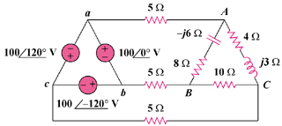

Figure 12.58
For Prob. 12.39.

